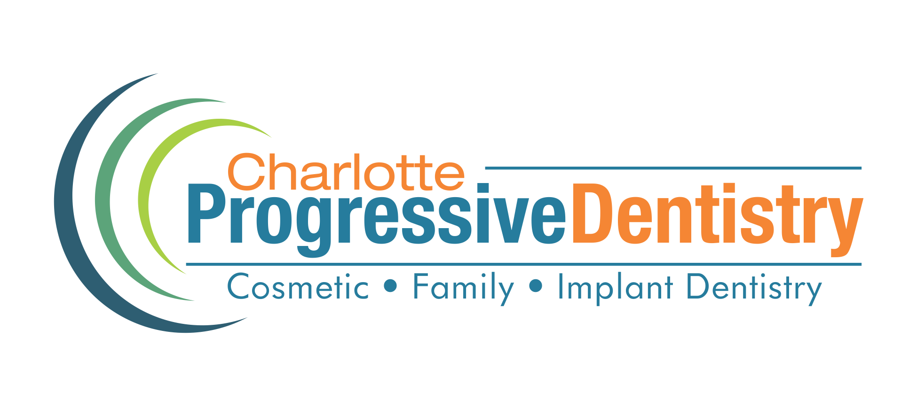

HIPAA Acknowledgment & Authorization to Release

Patient Name:_____________________________________________

Charlotte Progressive Dentistry is authorized to release protected health information about the above named patient to the entities named below. The purpose is to inform the patient or others in keeping with the patient’s instructions.

Entity to Receive Information Description of Information to be released
Check each person/entity that you Check each that can be given to person/entity
approve to receive information on the left in the same section

Voice Mail Results of lab tests/x-rays
Other: __________________________________

Spouse (Provide Name & Phone Number) Financial

______________________________________________ Medical as follows:_________________________

Parent (Provide Name & Phone Number) Financial

______________________________________________ Medical as follows:_________________________

Other (Provide Name & Phone Number) Financial

______________________________________________ Medical as follows:_________________________

I understand that I have the right to revoke this authorization at any time and that I have the right to inspect or copy the protected health information to be disclosed as described in this document. I understand that a revocation is not effective in cases where the information has already been disclosed but will be effective going forward.

I understand that information used or disclosed as a result of this authorization may be subject to redisclosure by the recipient and may no longer be protected by federal or state law.

I understand that I have the right to refuse to sign this authorization and that my treatment will not be conditioned on signing. This authorization shall be in effect until revoked by the patient.

I, ___________________________________________________ acknowledge that I have reviewed and received a copy of this office’s Notice of Privacy Practices explaining:
- How this office will use and disclose my protected health information
- My privacy rights with regard to my protected health information
- This office’s obligations concerning the use and disclosure of my protected health information
I understand that the Notice of Privacy Practices may be revised from time to time and that I am entitled to receive a copy of any revision upon request.

I also understand that if I have any questions or complaints, I may contact Charlotte Progressive Dentistry.

You may also contact the Secretary of the U.S. Department of Health and Human Services with any concerns regarding our privacy and security policies and procedures. Please contact our office for information on how to contact the U.S. Department of Health and Human Services.

Signature: _________________________________________Date: ____________________________________

Name (Print): _________________________________________Relationship to Patient:______________________

Office Use Only
We were unable to obtain a signed acknowledgment for the following reasons:
Patient refused to sign. Date:____________________________ An emergency situation prevented us from obtaining an acknowledgement
Communication barriers prohibited obtaining an acknowledgment Other:_______________________________________________

Attempt made by:______________________________________ Date:______________

